Traditional | often no private property; ownership by family or village in common
custom & tradition determine what is produced, how it is produced and for whom | 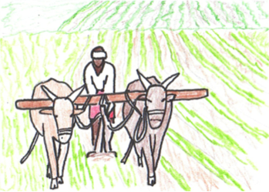
change and growth proceeds very slowly, new ideas discouraged | little trade with outsiders, services & products meet the needs of the family or tribe members

