Socialism | The government owns major industries. Some property is privately owned
Government should use its power to end poverty by taking control of major resources & providing public services | 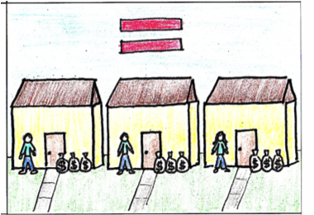
Many decisions about production distribution& use of resources are made by the government | The goal is a more fair distribution of income among all member of society. Basic needs (health care, transportation, housing, education) are provided free or at no cost

