Manorialsim | Each manor was self sufficient – produced its own food, shelter & clothing
Economic system of feudal Europe | 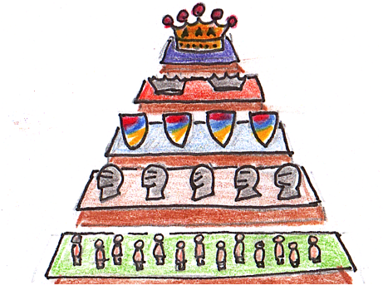
Consists of lord’s house and his serfs | Most people lived on a manor

