Free Enterprise | The ability to make a profit motivates people to risk their money in a business
Factories, farms & businesses privately owned & used as owners see fit with limited government interference | 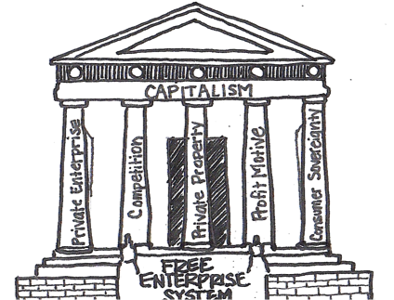
Individuals are free to buy and sell any legal products; businesses are free to lower prices, provide a better quality of goods & services and advertise to attract customers | The interaction between supply & demand determines prices. When demand is high, price goes up. When supply is high and demand is low, price goes down

