Communism | All workers should labor together & share equally. The economy is run for the benefit of all citizens
All major decisions on production, distribution & resource use are made by the government | 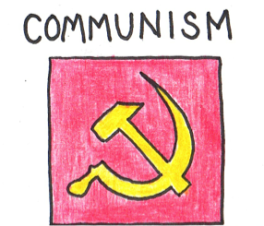
National ownership of all land, factors, farms, and resources; of private property ownership | The goal is a classless society – equality among all members

